**DAR ES SALAAM INSTITUTE OF TECHNOLOGY.**



**NAME: ASIA HABIB DOLA.**

**REGISTRATION NO: 160240210304.**

**PROJECT TITTLE: AN INTEGRATED GOVERNMENT REVENUE COLLECTION USING BLOCKS CHAIN TECHNOLOGY.**

**SUPERVISOR: MR JUSTUS M SELESTINE.**

**CLASS: BENG16-COE**

**DECLARATION.**

I **ASIA HABIB DOLA** declare to the best of my knowledge that the project presented here as a partial fulfillment of Bachelor Degree of Computer Engineering, is my own work and has not been copied anywhere or presented elsewhere.

|  |  |  |
| --- | --- | --- |
| **CANDIDATE NAME** | **SIGNATURE** | **DATE** |
| ASIA HABIB DOLA |  |  |
| **SUPERVISOR NAME** | **SIGNATURE** | **DATE** |
| MR. JUSTUS M SELESTINE |  |  |
|  |  |  |
|  |  |  |
|  |  |  |

**ABSTRACT.**

For every country, the revenue collection is collected at different ways, in our country they use a EFD machine and controlled number for making a payment. The aim of this project is to review the current of the centralized system of all activities that done during business process for all of the processes and to develop web based system to decentralized using block chain technology. Through this system should be able to organize the distributed system for all users, business owner to view their information as well as central government.

**ACKNOWLEDGEMENT.**

First and for most, I would carefully like to take this valuable opportunity to thank Almighty God , the creator of this world and all within it, for giving me health, strength and wisdom during the whole time of working of this project.

I also respect and thank my supervisor Mr. Justus M Selestine for supervising my project. I will always value his tireless effort and moral support he gave me.

**TABLE OF CONTENTS**.

**DECLARATION**………………………………………………….

**ABSRACT**………………………………………………………….

**ACKNOWLEDGEMENT………………………………………..**

**TABLE OF CONTENTS…………………………………………..**

**LIST OF ABBREVIATION………………………………………**

**LIST OF FIGURE…………………………………………………**

**CHAPTER ONE**……………………………………………………

1. INTRODUCTION……………………………………………

1.1 PROBLEM STATEMENT……………………………………….

1.2 OBJECTIVES…………………………………………………….

1.2.1 MAIN OBJECTIVE…………………………………………….

1.2.2 SPECIFIC OBJECTIVE………………………………………..

1.3 SIGNIFICANCE OF THE PROJECT……………………………

**CHAPTER TWO**……………………………………………………

1. **LITERATURE REVIEW**……………………………………
   1. THE EXISTING SYSTEM……………………………….

2.1.1 WEAKNESS OF EXISTING SYSTEM…………………..

2.1.2 BLOCK DIAGRAM OF EXISTING SYSTEM………….

2.2 PROPOSED SYSTEM……………………………………………..

2.2.1 ADVANTAGES OF PROPOSED SYSTEM……………………..

2.2.2 BLOCK DIAGRAM OF PROPOSED SYSTEM…………………

**CHAPTER THREE**……………………………………………………

1. **METHODOLOGY………………………………………………..**
   1. TYPES OF METHODOLOGY………………………

3.1.1WATERFALL METHODOLOGY…………………………...

3.1.2 SPIRAL METHODOLOGY…………………………………

3.1.3 AGILE METHODOLOGY………………………………….

3.1.4 PROTOTYPING METHODOLOGY……………………….

3.2 WHY PROTOTYPING……………………………………….

3.3 PROTOTYPE METHODOLOGY……………………………

3.3.1 PHASES OF PROTOTYPING METHODOLOGY………..

3.3.2 ADVANTAGES OF SYSTEM PROTOTYPING………….

3.3.3 DIS ADVANTAGES OF SYSTEM PROTOTYPING…….

**CHAPTER FOUR……………………………………………….**

1. **DATA COLLECTION………………………………………**
   1. INTERVIEW………………………………………………

4.1.1ADVANTAGES…………………………………………

4.1.2 DISADVANTAGES……………………………………

4.2 QUESTIONNAIRE………………………………………

4.2.1ADVANTAGES……………………………………….

4.2.2 DISADVANTAGES…………………………………

**CHAPTER FIVE…………………………………………………..**

**5.0 CONCLUSION………………………………………………..**

**5.1 RECOMMENDATION……………………………………….**

**REFERENCES……………………………………………………**

**LIST OF ABBREVIATION.**

EFD Electronic Fiscal Devices.

**LIST OF FIGURE.**

Figured 2.1.2 Block diagram of existing System…………………………

Figured2.2.2 Block diagram of Proposed System………………………..

Figured 3.3 Diagram of prototyping methodology……………………..

**CHAPTER ONE.**

1. **INTRODUCTION.**

The Government revenue collection is done by using the EFD (Electronic Fiscal Devices) machine, which is fully centralized to the server only .Once the transaction is done it is automatically stored to the server only, this system is not secure and reliable because once changes happen to the server some information can’t be retrieved back under normal circumstances as a result government and peoples information is lost .

By using the block chain technology the system can be decentralized by creating a subsystem that allow different customers to view the data or transactions that is done during a business processes.

Decentralized means the network operates on a user-to-user (or peer-to-peer) basis.

During block chain technologies there will no centralized version of this information exists for a hacker to corrupt.

Block chain is a decentralized distributed public digital record that is used to record transactions across many computers so that any involved record cannot be altered retroactively without the alteration of all subsequent blocks.

**1.1 PROBLEM STATEMENT.**

The government of Tanzania has been losing the income due to the reason behind that it has been depending on centralized systems which gave power to system administrator to temper with the system.

So, tempering can lead to comprise of data and safety of crucial government information.

There is no safety of data and it is easily for hacker to corrupt the all system and the can lead the loss of information or data.

So an Integrated Government revenue Collection using block chain technology seems to be the best option to overcome the problems.

We aimed to solve these problems by developing a system for collecting revenue that can solve all above problems and manages all activities. Through this system, users are able to interact with the system and view their respective information that is flexible.

**1.2 OBJECTIVES.**

This project has some objective to be implemented. Those objectives are categorized into two: main objective and specific objectives.

**1.2.1 MAIN OBJECTIVES.**

The main objective is to integrate the Government Revenue Collection Using Block chain technology and to make a decentralization of the system.

**1.2.2** **SPECIFIC OBJECTIVES.**

* To design a decentralized system by using a block chain technology.
* To develop a sub system to register users.
* To create a subsystem that allows all user or business to view all activity that can be done to the server during the transaction process.
* To design a network that allows sharing of the information.

**1.3 SIGNIFICANCE OF THE PROJECT.**

**CHAPTER TWO.**

**2.0 LITERATURE REVIEW**

This chapter describes existing system, weakness of existing system, block diagram of existing system and the proposed system, advantages of proposed system and block diagram of proposed system.

**2.1 EXISTING SYSTEM.**

The existing system for government in the collection of the revenue is fully centralized. Once the transaction is done from various business owners the information is stored automatically to the centralized server only. After that the system administrator sends files to the central government.

**2.1.1 WEAKNESS OF EXISTING SYSTEM.**

* It offers a greater security.
* When the central server is crash the entire system will be unavailable.
* It is easier for hackers to get files and to corrupt the whole system.
* High traffic can cause input and /output restricted access.

**2.1.2 BLOCK DIAGRAM.**

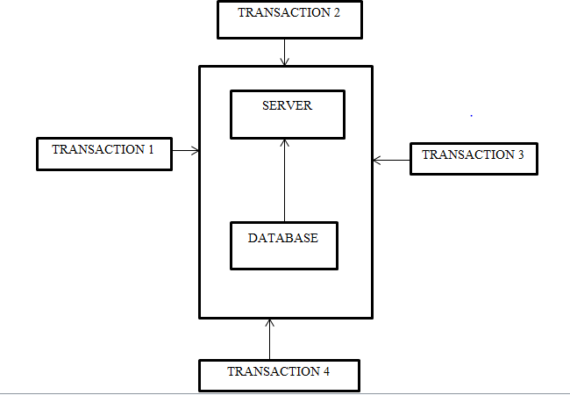

Fig 2.1.2 Block diagram of existing system.

**2.2 PROPOSED SYSTEM.**

The proposed system is web based that allow every ones who is registered to get the information and files.

Also it will use the block chain technology in which there is a decentralized server in which the information will be sent automatically to the central government once the transaction is done

The proposed system is a web based system and mobile system that enables users to make the interaction to the system.

**2.2.1 ADVANTAGES OF PROPOSED SYSTEM.**

* Empowered users.
* High quality data.
* Durability, reliability and longevity.
* Process integrity.
* Faster transactions.
* Lower transaction costs.
* Enhanced security.

**2.2.2 BLOCK DIAGRAM OF PROPOSED SYSTEM.**

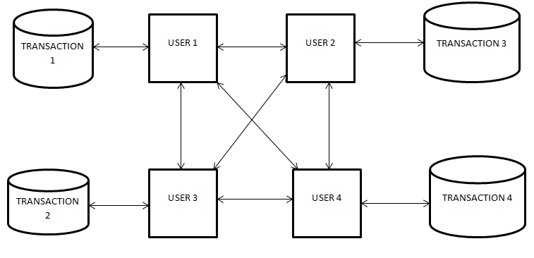

Fig2.2.2 Block diagram of proposed system.

**CHAPTER THREE.**

**3.0 METHODOLOGY.**

Methodology is a systematic, theoretical analysis of the methods applied to a field of study. It comprises the theoretical analysis of the body of methods and principles associated with branch knowledge. Basically, methodology deals with strategies on how to accomplish a project.

**3.1 TYPES OF METHODOLOGY.**

The following are some of the methodologies used in software developments.

**3.1.1 WATERFALL METHODOLOGY.**

The waterfall model is a linear sequential flow in which progress is seen as flowing steady downloads through the phase of software implementation. This means that any phase in the development process begins only if the previous phase is complete.

**3.1.2 SPIRAL METHODOLOGY.**

It combining element of both design and prototyping-in-stage in an effort to combine advantages of top-down and bottom-up concepts. This model of development combines the features of the prototyping model and waterfall model.

**3.1.3 AGILE METHODOLOGY.**

It is based on iterative and incremental development, where requirements and solutions evolved through collaboration between cross-functional teams.

**3.1.4 PROTOTYPING METHODOLOGY.**

The prototyping model is a systems development method(SDM) in which a prototype (an early approximation of a final system or product ) is built, tested, and then revised as necessary until an acceptable prototype is finally achieved from which the complete system or product can now be developed**.**

**3.2 WHY PROTOTYPING**

In this project, Prototype Methodology is used in to develop the project up to the final stage due to the following reasons.

1. Users who are going to use the system are located near so it is easy to reach them anytime if they are needed for any input to the project.
2. Errors can be detected much earlier.
3. Sometime users cannot identify what he/she wants at requirement but will identify them when he/she see the working prototype.
4. The user become of the aware of how to use the system early so it will reduce the training period.
5. Since the system will need high interaction with end-users so as at the end to deliver the usable product.

**3.3 PROTOTYPE METHODOLOGY**

Prototyping based methodology is oriented in developing a working model of the product and correcting it according to user suggestions before releasing the final product. The analysis design and implementation phases are done repeatedly until the system is complete. The following is the block diagram of prototype methodology.

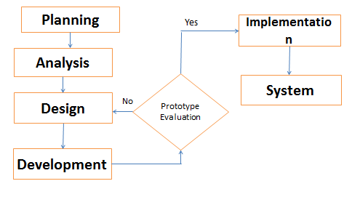

Fig3.3 Prototyping diagram.

**3.3.1 PHASES OF PROTOTYPE METHODOLOGY.**

This section describes what is done in each phase and which tool is used in the corresponding phase.

**3.3.1.1 PLANNING:**

The purpose of this phase is to perform a preliminary investigation to evaluate an IT-related business opportunity or problem. The preliminary investigation or planning phase is very critical since it affects the entire development process. The better planning phase it ensures better and less complex system development process. Planning phase helps to anticipate costs and benefits of a new system.

**3.3.1.2 ANALYSIS:**

This involves critical analysis and evaluation of information obtained through interview and Questionnaire. The analysis phase answers the questions “who will use the system”, “what the system will do”, and “where and when it will be used”

**3.3.1.3 DESIGN:**

Design phase deals with creating physical models that satisfy all the requirements documented for the system. Also the designing phase decide how the system will operate, in terms of the hardware, software, network infrastructure include the user interface, forms, and reports that will be used.

In designing process, it comprises the following steps;

1. Development of design strategy.

It decides whether the system will be developed or buying an existing software package.

1. Development of the basic architecture design for the system.

It describes the hardware, software, and network infrastructure that will be used.

1. Development of database and file specifications.

These define exactly what data will be stored and where they will be stored.

1. The analysis team develops the program design.

It defines the programs that need to be written and exactly what each program will do.

**3.3.1.4 IMPLEMENTATION.**

Implementation involves the implementing and evaluating the system.

There are three phases in this stage;

1. System construction.

The system construction is built and tested to ensure it performs and designed.

1. The system is installed: Installation is the process by which the old system is turned off and the new one is turned on.
2. Establishment of support plan for the system.

This plan usually deals with the way for identifying major and minor changes needed for the system.

**3.3.2 ADVANTAGES OF PROTOTYPING METHODOLOGY.**

* This ensures a greater level of customer satisfaction and comfort.
* New requirements can be easily accommodated as there is scope for refinement.
* Missing functionalities can be easily figured out.
* Errors can be detected much earlier thereby saving a lot of effort and cost, besides enhancing the quality of the software.
* The developed prototype can be reused by the developer for more complicated projects in the future.
* Flexibility in design.

**3.3.3 DIS ADVANTAGES OF SYSTEM PROTOTYPING.**

1. Leads to implementing and then repairing way of building systems hence takes longer to develop.
2. Practically, this methodology may increase the complexity of the system as scope of the system may expand beyond original plans.
3. Incomplete application may cause application not to be used as the full system was designed.
4. Incomplete or inadequate problem analysis can arise.

**CHAPTER FOUR.**

1. **DATA COLLECTION.**

Data collection is the process of gathering and measuring information on variables of interest, in an established systematic fashion that enables one to answer stated research questions, test hypotheses, and evaluate outcomes.

The following methods of data collection will be used:

1. Questionnaire.
2. Interview.

**4.1 QUESTIONNAIRE:**

A series of questions designed to elicit/ draw specific information about an area of study or interest. Questionnaire is a quantitative kind of data collection.

Is a research instrument consisting of a series of questions or other types of prompts for the purpose of gathering information from respondents.

**4.1.1 ADVANTAGES OF QUESTIONNAIRE.**

* They are cheap.
* They do not require as much effort from the questioner as other methods.
* Often have standardized answers that make it simple to compile data.
* Can provide information about participants’ internal meanings and ways of thinking
* Useful or exploration as well as confirmation.
* Open-ended items can provide detailed information in respondents’ own words.

**4.1.2 DIS ADAVANTAGES OF QUESTIONNAIRE.**

* People filling out questionnaires may not recall important information and may lack self-awareness.
* Data analysis can be time consuming for open-ended items.
* Usually must be kept short, hence it may lack important questions.

**4.1.3 QUESTIONNAIRE SAMPLE QUESTION.**

* Is there any need to have another system for collecting a revenue?

YES……………. NO…………………..

* Is your existing system for collecting revenue is secured?

YES………… NO………….

* Do you get any challenges on the existing system you use?

YES…………. NO………………

* Do you want to changes on the existing system for collecting revenue?

YES…………. NO……………

* Do you think the proposed system will solve the problems?

YES………… NO……………

**4.2 INTERVIEW.**

An interview is a conversation where questions are asked and answers are given. Also an Interview is the conversion between two or more people where questions are asked by interviewer to elicit facts or statement from interviewee.

**4.2.1 ADVANTAGES OF INTERVIEW.**

i. Accurate screening

ii. Capture verbal and non-verbal ques.

iii. Keep focus

iv. Capture emotions and behaviors

**4.2.2 DISADVANTAGES OF INTERVIEW.**

i. Cost.

ii. Quality of data by interviewer.

iii. Manual data entry.

iv. Limit sample size**.**

**CHAPTER FIVE.**

**5.0 CONCLUSION.**

This report demonstrates completion of the project one for the year 2018/2019. The report contains introduction, literature review, and Methodology and data collection. In this report it has been demonstrate that the new proposed system has some functionality which is eliminate the problems of the current system.

**5.1 RECOMMENDATION.**

The system with its functionality should be used in order to avoid most of lost which might happen when the current system is still used in implementation of the per timer management system.